**Requirements for MOOC Portal with Access to Forum**

DRAFT

*Overview*

Skillsoft MOOCs will be delivered through the use of a portal product (built on Advantage templates). The use of the portal will allow the MOOC to be a product that can be sold and delivered on various client sites in conjunction with Skillsoft Services. One facet of the MOOC experience is learner collaboration. The collaboration is focused within each group/cohort of the MOOC.

The use of a forum will allow MOOC participants from the same company to collaborate with each other. We’ll use API’s to create learners and seamlessly drop them in the forum with a single click in the portal. The forum will be available to the learners through a link/button in several places within the MOOC portal.

Using Vanilla Forums as an example, here’s a prototype of a MOOC built for Acme Products. Acme has purchased the HTML5 and Angular JS MOOCs. The currently have two cohorts schedule for each topic.

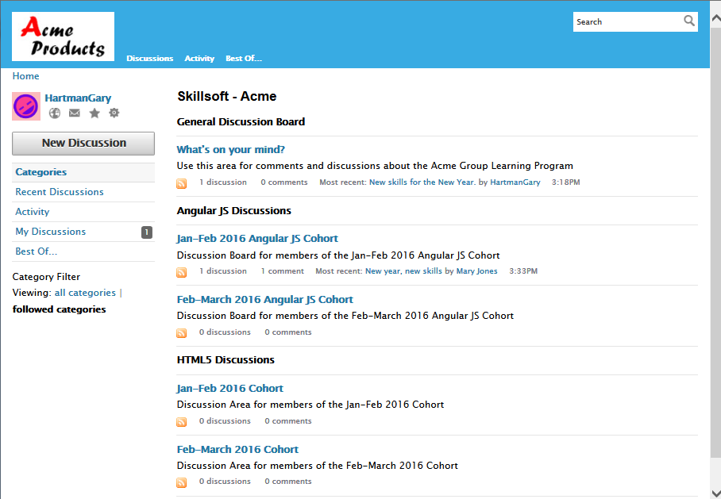

Here are some comments from the Jan-Feb Angular JS Cohort Discussion Board:

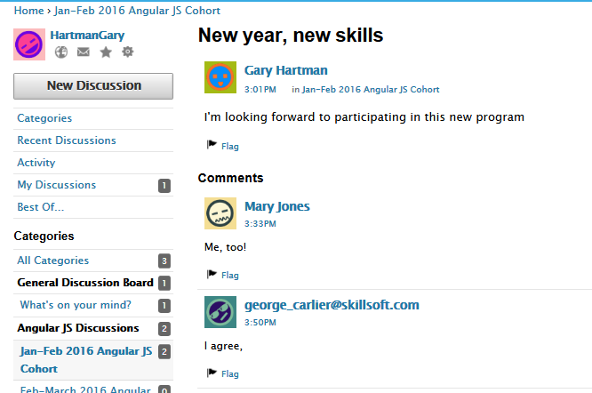

*Requirements*

* Forum provider will need to meet Skillsoft Hosting minimum service levels.
* Each distinct client will need a forum(s) that are separated from other clients/sites.
  + Option A – The client-specific forum will have Categories for each purchased MOOC, and sub-categories for each group/cohort (See sample above.). This will allow learners to see other MOOC/groups’ discussions, however it will be very clear which discussion area is for their MOOC and group.
  + Option B – There will be a client-specific forum for each purchased MOOC. Within the forum will be discussion areas for each group/cohort. This will allow learners to see other groups’ discussions, however it will be very clear which discussion area is for their group. Learners will not be able to see other learners who are participating in other MOOCs.
* Learners must easily view their MOOC and group/cohort discussions within the forum.
* The link/button to the forum from within the portal will need to seamlessly pass the learner into the correct forum.
  + This process will need to establish the learner’s ID within forum on the first access.
  + This process will need to pass the learner to a forum that is client specific.
  + We will pass user information like First Name, Last Name, email and profile picture.
* The link/button to the forum from within the portal should not have to be configured for each client. However it is expected that the forum will need to be setup and configured for each client (Skillsoft Services).
* The forum should not be accessible unless linked to from the portal.
* The forum should be able to be branded for either Skillsoft or client.
* There should be a repeatable process that Skillsoft Services can use to easily setup the forum for each client and applicable MOOCs.